User Manual: Label Matrix Basics

| july-20 |

**Document Overview**

**Documentation Goals**

This documentation is intended to provide instruction for the basics of ***Label Matrix****.*

**Table of Contents**

**Label Matrix Basics** 3

**Auto Print** 7

Automatic Printing from a Source Database 7

To Use Auto Print 7

**Printing Case Labels** 8

Advantzware Data 8

Data for Multi-User License 8

Case Labels 9

Storing Specific Load Tags to Print 9

Creation Screen 9

Confirmation 10

**Printing Load Tags** 10

Advantzware Data 10

Data for Multi-User License 11

Storing Specific Load Tags to Print 11

Printing Load Tags 12

**Combination Field** 13

How to Create a Combination Field with Label Matrix 13

Combination Wizard 13

# **Label Matrix Basics**

You can create new labels from scratch, but it is probably easier to modify an existing one.

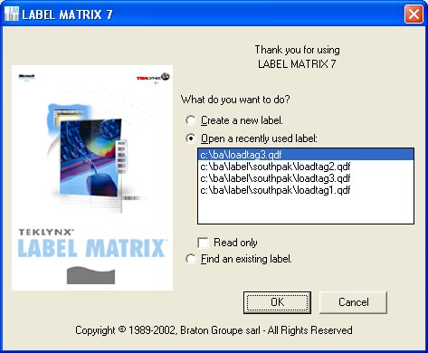

A “Sample” of the label that you selected is displayed when you say “OK” on the above screen.

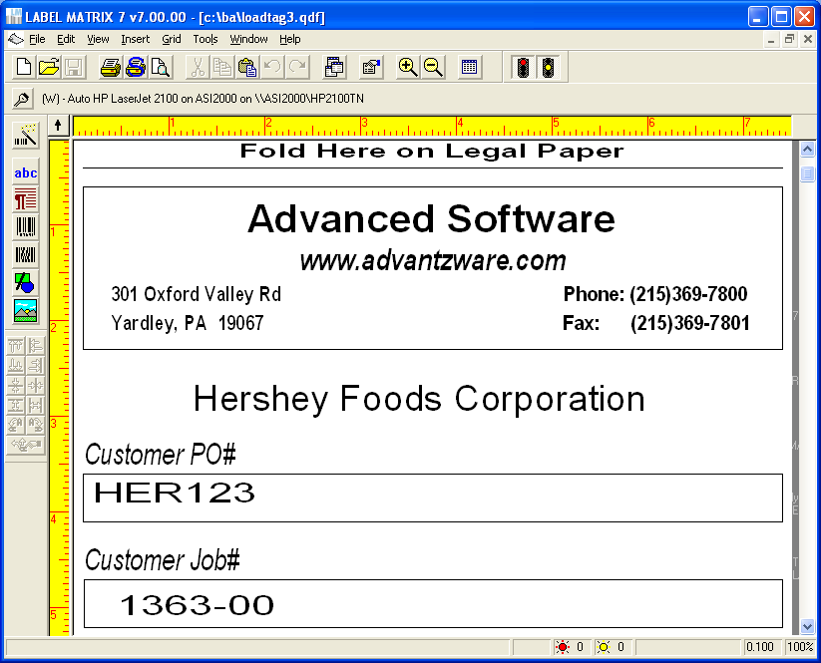

There are several types of data that Label matrix handles. The two most common are:

1. Constant data (such as your company name & address)

2. Database data (such as the PO #) that comes from our database.

You can single click a field to put it into “modifiable status” **[** red brackets**].** After a single click you can drag a field. With a double click you can change the information in a text field.

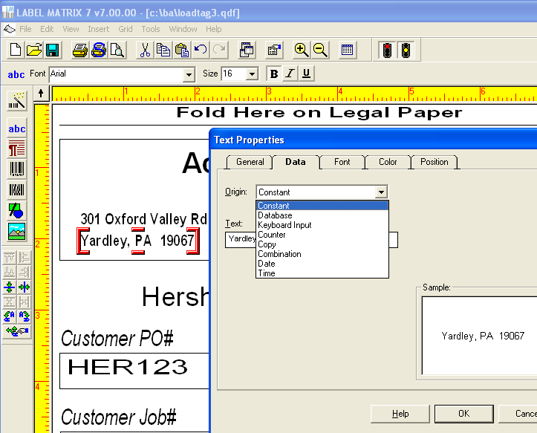

Database data allows you to select which of the fields that are passed from Advantzware you want to display on the labels.

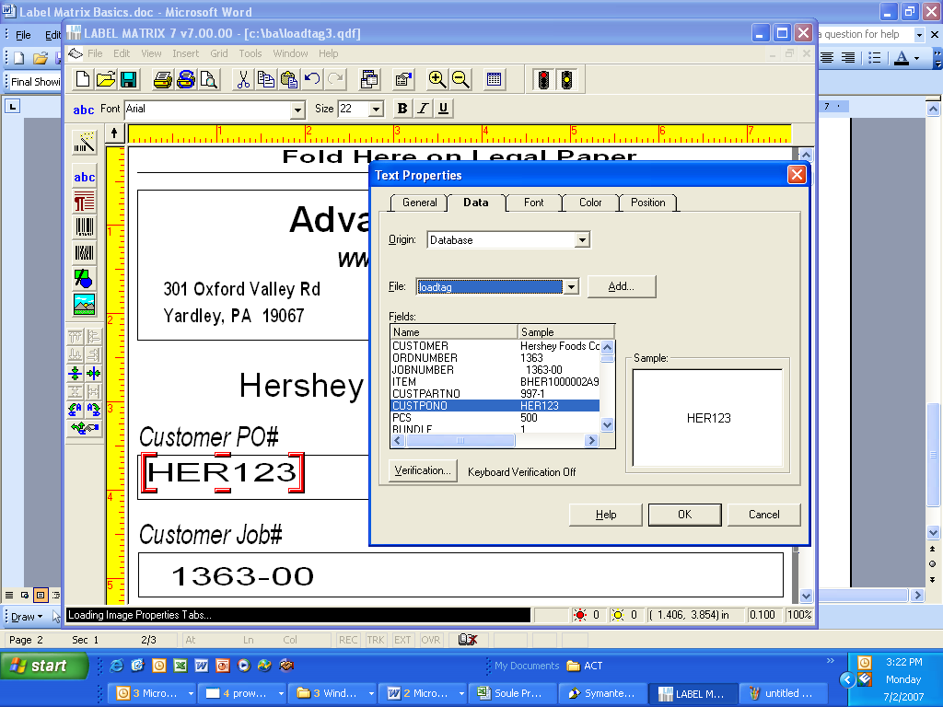

To add new data, you place the cursor in the desired area (a large + sign shows the target area), then click ABC to add either constant or database data.

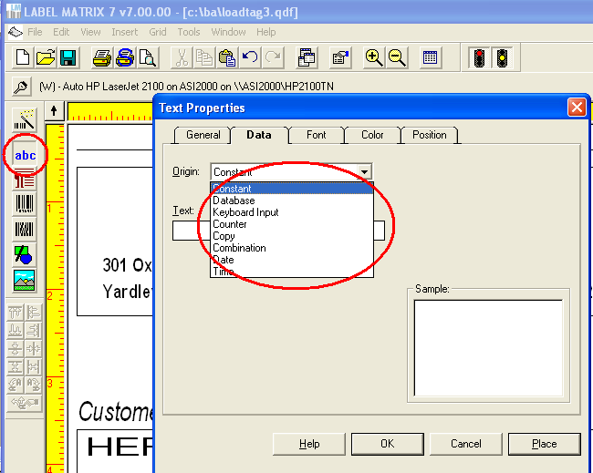

To add a bar code simply select the bar code icon and then select the database field that you want to add as a bar code.

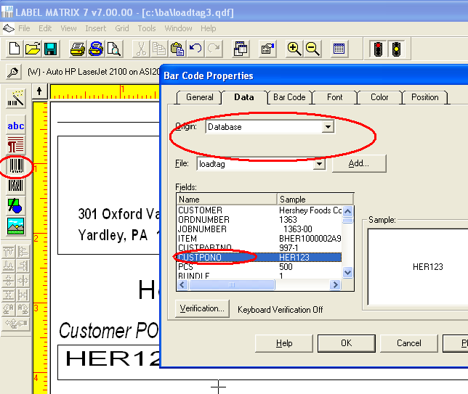

You can also change the font, size or color of any piece of data on the label.

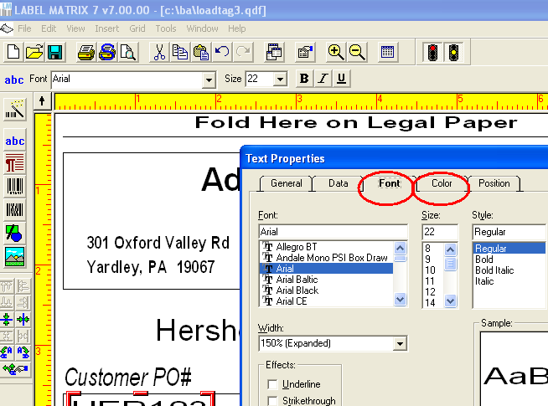

The newly modified label should now be saved as a new name (File, save as…)

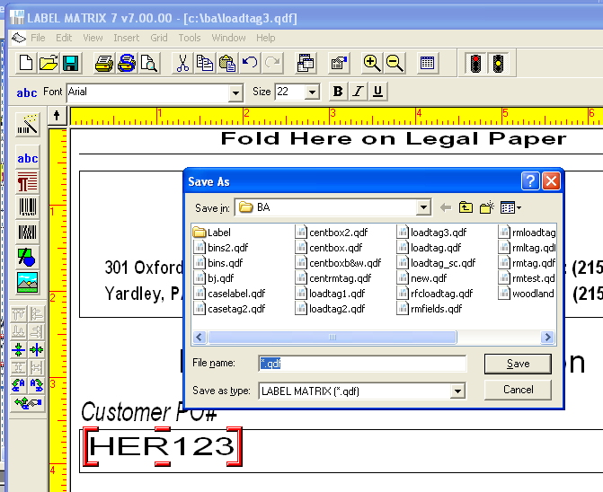

# **Auto Print**

## Automatic Printing from a Source Database

Some editions of this program feature an "AutoPrint" tool that enables you to print labels based on data that is constantly changing. It allows the automation of print jobs where data files are sent from a mainframe or an accounting or manufacturing process.

AutoPrint retrieves the data in the text file when available, then prints, whereas Advantzware overwrites the data each time that ***“O”-“U”-“7”*** or ***“O”-“U”-“10”*** are run.

Please Note: The AutoPrint feature may only be used with one dBase or ASCII file with sequential access.

### To Use Auto Print

Please Note: If you are using AutoPrint in conjunction with the program's print engine, LMWPRINT. (LMWPRINT must first be launched in order to run AutoPrint.)

* First, create a database. (Note that this database will be deleted after the print job – FoxPro will need to create a new database using the same name and location as this database in order for AutoPrint to recognize and print the next print job).
* Open your label design file.
* Add the database to the label using Sequential Access.
* Select Label Properties from the File menu and click on the AutoPrint tab. Check the Enable AutoPrint box and then click the Advanced button.
* Set the Poll setting which will determine how often AutoPrint searches for the new database file. Click OK and then click OK again to return to the main label design screen.
* Add any text or bar code images to the label by using the Database data origin and selecting the desired field to associate with each image.
* Save the label design.
* Now initialize the first print job (select the All print range or print from LMWPRINT); labels should print and then the program will keep searching for this same database file name. When it is found it will initialize the print job automatically.
* A dialog box will display on the desktop showing that AutoPrint is working (this dialog cannot be minimized. However, it can be dragged to the bottom of the screen if desired).

# **Printing Case Labels**

## Advantzware Data

The menu ***“O”-“U”-“10”*** dumps data into a text file that the label software reads to print a case label.

N-K-1 BarDir

This character value lists the bar code software used which dictates the text file format that is downloaded. Most clients set this to SSLabel which is short for Sharp Shooter Label Matrix.

N-K-1 BarDir Description Field

Stores the folder / directory for storing the text file that is used with the label matrix or bar code anything software including finished goods load tags, work in process tags and raw material tags are stored as text files under the directory (folder) as defined by the description.

There must be a folder (directory) on the machine that stores the Label Matrix software, labels and text file for Advantzware data.

Single user licenses are normally loaded on the disk drive C:\BA\LABEL. Labels are created from the machine that label matrix is loaded on.

#### N-K-1 CasTag

Advantzware creates a text file and dumps this into a folder. The text file is determined based on the N-K-1 CasTag integer value. If the value is 0, then the text file is pulled from the control parameter N-K-1 BarDir via the disk drive directory defined on the description field. Most clients name this BA \ LABEL.  The label matrix forms most often also reside in this directory.

### Data for Multi-User License

Label Matrix also has a server-based product which would allow all users to point to one copy of this label generation software and share labels. Sharp Shooter computer users such as forklift mounted computers or handheld devices may connect to the server via terminal services communications. Under this scenario, all the users will not want to share the same text file.

The V10 users file under menu N-U has a field called Pallet Load Tag / Case Label Text File Path. Each user must define a unique text file location that has been created on the network server. Once updated, the user will create labels specific to their orders without unwanted merging with other users.

Advantzware creates a text file and passes it to a text file. The text file is determined based on the N-K-1 CaseTag integer value. When the value is 1, then the text file is pulled from the user file, therefore the Advantzware data will be transferred to the users text file when printing a case label. If the user file is blank, then the logic works as if the integer value is 0 as explained above.

## Case Labels

### Storing Specific Load Tags to Print

The control parameters N-K-1 CasTag and N-K-1 CasLabel dictate all the unique printing logic for printing case labels via the menu options O-U-10.

N-K-1 CasLabel Logical Value = YES will turn on logic to print CASE LABELS per item. Customer shipto or Customer. Case Labels to be printed will transfer to the O-U-10 field based on the following hierarchy.

A) Finished Goods Item File - Total/CP# Folder

B) N-K-1 CaseLabel View Form by Shipto when A is blank

C) N-K-1 CaseLabel View Form by Customer when A & B are Blank

D) N-K-1 CaseLabel View Tab, Character Field when A, B and C are Blank

The finished goods item file can store a specific pallet tag by item under the Totals/CP# tab. An F1 on this field provides a search of the disk drives to find the proper label.

When Printing the Case Label, once an order # is entered, the program will display the item.

This will also display the CASE LABEL based on the hierarchy noted above. If a unique case label exists for an items customer part number, this label will display. If the item does not have a unique case label, then the label by customer’s ship to location will print.

Next, the program will search for a unique label by the customer. Finally, if there are no unique labels defined, the program will search the CaseLabel character value. If all are blank, the program allows the end user to pick a label from the Bar Code Software Program.

Please Note: Any label that displays on the O-U-10 print screen may be changed before printing. A new toggle box called AUTOPRINT will automatically launch Label Matrix and print the selected file with the printing the Label.

If the label is blank in the Totals/CP# tab for the finished goods item, then the system looks for a unique tag by Customer Ship To location or by Customer as defined in the View Forms tab.

If options A, B and C are above are blank then the program will search for a unique pallet tag for the customer code only. As you can see below, only the customer code is defined.

### Creation Screen

The case label creation screen provides many options to select what fields are downloaded to the text file. The number of duplicate labels to print via the integer value defined on the N-K-1 CasLabel parameter. Then total number of case labels to print for a specific order quantity is dictated by the N-K CasLabel Decimal Value. Decimal Value = 0 will generate just 1 unique case labels.

This option would be used when producing case labels for each pallet produced on the production floor. Decimal Value = ? will default the number of case labels to 0 so that the number of tags to be created must be manually entered. Decimal Value = 1 will to generate the total case labels required by dividing the order quantity by the case count. This option is used when printing in the office before actual production.

### Confirmation

Once you click the “OK button to create the case label, the following worksheet confirms the exact item, order quantity, case count, cases per pallet and other information. Other temporary fields may be added to the worksheet such as color, lot#, weight and other fields that customers may need added in the future. The DONE button will actually dump the data to the text file and simultaneously print the case label if the AUTOPRINT option is selected.

Please Note: The label matrix software also has the ability to prompt for temporary fields prior to printing the label.

When you select a label format a sample of it is displayed. The “grid” icon on the top of the screen will allow you to display the file of load tag data that was created in Advantzware. You then can use the printer icon, (or the menu option File/ Print) to print the tags.

You can also modify tags and save a custom one to use for your plant.

# **Printing Load Tags**

## Advantzware Data

The menu ***“O”-“U”-“10”*** dumps data into a text file that the label software reads to print a label. N-K-1 Loadtag character value lists the bar code software used which dictates the text file format that is downloaded. Most clients set this to SSLabel which is short for Sharp Shooter Label Matrix.

N-K-1 BarDir

This character value lists the bar code software used which dictates the text file format that is downloaded. Most clients set this to SSLabel which is short for Sharp Shooter Label Matrix.

N-K-1 BarDir Description Field

Stores the folder / directory for storing the text file that is used with the label matrix or bar code anything software including finished goods load tags, work in process tags and raw material tags are stored as text files under the directory (folder) as defined by the description.

There must be a folder (directory) on the machine that stores the Label Matrix software, labels and text file for Advantzware data.

Single user licenses are normally loaded on the disk drive C:\BA\LABEL. Labels are created from the machine that label matrix is loaded on.

#### N-K-1 CasTag

Advantzware creates a text file and dumps this into a folder. The text file is determined based on the N-K-1 CasTag integer value. If the value is 0, then the text file is pulled from the control parameter N-K-1 BarDir via the disk drive directory defined on the description field. Most clients name this BA \ LABEL.  The label matrix forms most often also reside in this directory.

### Data for Multi-User License

Label Matrix also has a server-based product which would allow all users to point to one copy of this label generation software and share labels. Sharp Shooter computer users such as forklift mounted computers or handheld devices may connect to the server via terminal services communications. Under this scenario, all the users will not want to share the same text file.

The V10 users file under menu N-U has a field called Pallet Load Tag / Case Label Text File Path. Each user must define a unique text file location that has been created on the network server. Once updated, the user will create labels specific to their orders without unwanted merging with other users.

Advantzware creates a text file and passes it to a text file. The text file is determined based on the N-K-1 BarDir integer value. If the value is 1, then the text file is pulled from the user file, therefore the Advantzware data will be transferred to the users text file when printing a loadtag label. If the user file is blank, then the logic works as if the integer value is 0 as explained above.

## Storing Specific Load Tags to Print

The control parameters N-K-1 BarDir and N-K-1 LoadTag dictate all the unique printing logic for printing pallet tags via the menu options ***“O”-“U”-“7”*** or the Loadtag Icon on the Item folder of ***“O”-“U”-“1”***.

N-K-1 BarDir Logical Value = YES will turn on logic to print LOADTAGS per item or customer.

LoadTag Label will transfer to the ***“O”-“U”-“7”*** field based on the following hierarchy.

A) Finished Goods Item File - Total/CP# Folder

B) N-K-1 BarDir View Form by Shipto when A is blank

C) N-K-1 BarDir View Form by Customer when A & B are Blank

The finished goods item file can store a specific pallet tag by item under the Totals/CP# tab. An F1 on this field provides a search of the disk drives to find the proper label. When Printing the Load Tag, once a order # is entered, the program will display all items. This will also display the LOADTAG LABEL based on the hierarchy noted above.

If a unique Load Tag label exists for an items customer part number, this form will display. If the item does not have a unique Loadtag label, then the label by customers shipto location will print. Next, the program will search for a unique label by the customer. Finally, if there are not unique labels defined, the program will allow the end user to pick a label from the Bar Code Software Program. Please note, any label the display on the O-U-7 print screen may be changed before printing. A new toggle box called AUTOPRINT will automatically launch Label Matrix and print the selected file with the printing the Load Tag.

If the label is blank in the Totals/CP# tab for the finished goods item, then the system looks for a unique tag by Customer Ship To location as defined in the View Forms tab.

When Printing the Load Tag, once a order # is entered, the program will display all items.

If options A and B are above are blank, then the program will search for a unique pallet tag for the customer code only. As you can see below, only the customer code is defined.

## Printing Load Tags

***“O”-“U”-“1”*** has an Icon shown below. This same screen is available via ***“O”-“U”-“7”*** (load Tag creation).

The load tag creation screen provides many options to select what fields are downloaded to the text file. The number of duplicate tags to print is dictated by the customer file field called No of Load Tags. This allows up to four load tags per pallet. Each tag will have the same tag number for scanning however it is duplicated based on this field. If this is blank, the program will search the integer value defined on the N-K-1 Loadtag parameter.

Then total number of load tags to print is dictated by the N-K LoadTag Decimal Value.

Decimal Value = 0 will generate just 1 unique load tag. This option would be used when producing load tag for each pallet produced on the production floor. The N-K-Caselabel value will allow scanning a bar coded case lable to automatically preload the loadtag criteria.

Decimal Value = ? will default the number of load tags to 0 so that the number of tags to be created must be manually entered.

Decimal Value = 1 will to generate the total load tags required by dividing the order quantity by the pallet count. This option is used when printing in the office before actual production. Since the actual quantity produced is unknown at this time, the ASI version will create one additional tag that will have a blank unit count. When receipts are scanned via sharp shooter, the program will prompt for a unit count for this load tag. When printing just 1 tag at a time, the user normally will set the logical value to Yes to prompt for a case label bar code.

#### N-K Loadtag Logical value = YES

This will prompt to scan a Case Tag Label to print a Load Tag and bypass the existing load tag print selection menu. The case label must created by the ***“O”-“U”-“10”*** program with the ASI format. Once the case label is scanned, the fields on the normal LOADTAG screen will be automatically populated with the job number, order number and finished goods item number as beginning and ending numbers. This normal print selection menu will be bypassed and then the screen will import the case tag fields to update the quantity per unit/case, units/cases per pallet and partial unit/case. Once SAVED, the system will download the data and the warehouse person can print the LOAD TAG label via the Label Matrix software.

Once you hit the “Create Tags” button the text file is sent to the BA/LABEL directory.

When you run Label Matrix you will be able to select the label format (once you used one it is displayed in the “Open recently used label” area).

When you select a label format a sample of it is displayed. The “grid” icon on the top of the screen will allow you to display the file of load tag data that was created in Advantzware. You then can use the printer icon, (or the menu option File/ Print) to print the tags.

You can also modify tags and save a custom one to use for your plant.

# **Combination Field**

## How to Create a Combination Field with Label Matrix

* Specify Combination as the image origin type from the data tab.
* Click the Use Wizard button on this screen to let the Combination Wizard guide you through the setup. The Combination Wizard steps you through the process of adding a combined image to your label; it helps you build an expression. As long as the Add another data origin to combined image option is checked, you can select and set up data origins to add to the expression.

### Combination Wizard

The Combination Wizard steps you through the process of adding a combined image to your label; it helps you build an expression. As long as the Add another data origin to combined image option is checked, you can select and set up data origins to add to the expression.

Once you choose your first field type, click the next button. As long as the Add another data origin to combined image option is checked, you can select another data origin to the expression. Once you choose your next field type, click the next button. Once you select the database choose the field from that database.

When you are finished building your expression, de-select the Add Another…option to gray out all choices and click Next to view your completed expression. If you decide at this point that you want to change any part of the expression, click the Back button located at the bottom of the dialog to go back and make changes.

After choosing Finish to end the wizard, the screen will show you a sample of the field which you created.